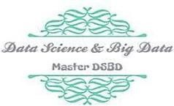

State of the Art knowledge graphs

Réalisé par : Encadré par :
AOUTOUF Abderrahim Pr .El Ghazouani Mohamed Ouirra Salah Eddine Analyse prédictive
El Otmani Chadi Otman

Filière : M2 BIG DATA Année universitaire : 2024-2025
Université Hassan II – Faculté Des Sciences Ben M’SIK

Dédicace

Nous remercions Dieu Tout-Puissant de nous avoir donné la santé et la volonté de commencer et de terminer cette mémoire.
Merci à nos chers parents pour tous leurs sacrifices, leur amour, leur tendresse, leur soutien et leurs prières durant mes études.
Merci à toute notre famille de nous avoir soutenus tout au long de notre parcours universitaire et toutes les personnes qui nous ont aidés à mettre en place ce projet, de près ou de loin.
Que ce travail soit l'accomplissement de vos soi-disant vœux, le fruit de votre soutien inlassable, Merci d'être toujours à nos côtés.

Remerciements

Au terme de ce travail nous remercions Mr El Ghazouani Mohammed pour son encadrement, pour sa patience, se rigueur, son soutien moral, ses encouragements et sa disponibilité durant la préparation de ce projet.
Nous remercions également les co-encadrants pour leur lecture attentive du rapport ainsi que pour les remarques pour l’amélioration de notre travail.
Nous remercions tous les professeurs du département d'informatique de la Faculté des Sciences Ben m’sick pour la formation qu’ils nous ont fournis et pour la création d'un environnement de travail adapté pour l'achèvement de ce projet. Enfin, nous exprimons notre profonde gratitude à nos parents pour nous avoir élevé, et nous avoir fourni un soutien sans faille et des encouragements continus tout au long de nos années d'études. Cet accomplissement n'aurait pas été possible sans eux. Merci beaucoup.

Table des matières
Introduction 6
1.General Context 6
2.Use Case 7
Litterature Review 8
1. State of the Art 8
Article 1: Deep learning and knowledge graph for image/video captioning 8
Article 2: Knowledge Graph Construction for Remote Sensing and Surveying 11
Article 3 : Steinmetz and Sattler - 2021 - What is in the KGQA Benchmark Datasets Survey on Challenges in Datasets for Question Answering 13
Article 4 : Hänsel et al. - 2023 - From Data to Wisdom Biomedical Knowledge Graphs for Real-World Data Insights 16
Article 5 : Lu, F., Cong, P., & Huang, X. (2023). Utilizing Textual Information in Knowledge Graph Embedding 20
2.Comparative Table : 22
3.Table Synthesis 23
Methodology 24
1.Knowledge Extraction 24
Entity and Relationship Extraction 24
Structuring Data 24
Ontology Definition 24
Data Integration 24
Refinement of Relationships 25
Backend Development 25
User Interface Design 25
Query Mechanism 25
Testing 25
Deployment 26
Maintenance and Updates 26
Architecture 27
1.Case study 27
2. Key Concepts 28
Natural Language Processing (NLP) 28
Large Language Models (LLMs) 28
Knowledge Graphs (KGs) 28
Resource Description Framework (RDF) 29
Ontology 29
SPARQL Query Language 29
3. Tools to Use 29
Neo4j 29
spaCy 30
Rasa 30
Python 30
Cypher Query Language 30
4. System Architecture 31
Input Layer 31
Knowledge Graph Construction 31
Backend 31
Frontend 32
Middleware 32
Conception and Application 33
1. Sequence Diagram 33
1.2 Explanation 33
2.Knowledge graphe 34
Knowledge Graph Creation Process for Our Project 35
1. Data Collection and Preprocessing 35
2. Entity Extraction Using NLP 35
3. Relationship Extraction 37
References 38

Introduction

1.General Context

Knowledge graphs (KGs) are a powerful way to represent and organize information in a structured, interconnected way. They consist of entities (nodes) and the relationships (edges) between them, allowing complex data to be captured in a way that is both machine-readable and human-understandable. By linking various data sources into a unified, semantically rich structure, knowledge graphs enable better data discovery, reasoning, and decision-making.
The goal of this project is to understand how to use knowledge graphs and their various techniques to transform raw data into structured, semantic representations. By exploring methods such as data extraction, entity recognition, relationship mapping, and graph-based reasoning, the project aims to demonstrate how these graphs can enhance data integration and support advanced applications like semantic search, decision-making, and contextual analysis
The problem addressed by this project is how to effectively transform unstructured or semi-structured data into usable knowledge graphs that can represent complex relationships and semantics. Despite the growing availability of large datasets, a major challenge lies in efficiently extracting relevant entities, defining meaningful relationships, and integrating data from diverse sources into a unified graph. Additionally, maintaining the quality and relevance of these knowledge graphs over time, as new data and knowledge emerge, presents another significant challenge.

2.Use Case

In the case of this project , the big Goal is to simplify understanding long and complicated law texts to the normal user through interactive interfaces like a Chatbot or a Web app . and that’s by turning these long texts into knowledge graphs fed to the system to query their responses .
The project is divised as follows :
- Litterature Review : we’ll compare differenet approached and uses of Knowledge Graphs .
- Methodology : detailed explanation of the process of analyzing , schemas and system building .
- Architecture and tools Used
- Realization phase : the application of the methodology and analyzing the results .

Litterature Review

State of the Art

Article 1: Deep learning and knowledge graph for image/video captioning

Methodology

The methodology aims to integrate deep learning architectures with knowledge graph-based approaches to generate rich, context-aware captions for various types of visual content. This system works across three main tasks: Image Captioning, Video Captioning, and Dense Video Captioning, each addressing unique challenges and utilizing both visual and contextual information to enhance caption accuracy.

Objective

The objective of this methodology is to develop an integrated system for generating rich, context-aware captions for visual content—whether static images, dynamic video sequences, or multiple events within untrimmed videos—by combining deep learning techniques (such as CNNs, LSTMs, and 3D CNNs) with knowledge graph-based enrichment. The system aims to bridge the semantic gap between low-level visual features and high-level concepts, enhancing the accuracy, fluency, and relevance of generated captions across diverse multimodal content. This approach seeks to improve both individual object-level understanding and complex event-based descriptions, providing detailed, coherent, and semantically rich textual outputs for images and videos.

a. Image Captioning:

The objective of image captioning is to generate accurate, meaningful, and contextually relevant textual descriptions for static images. The goal is to bridge the semantic gap between low-level visual features (such as pixels, textures, and colors) and high-level concepts (such as actions, objects, and relationships) by integrating deep learning with external knowledge from knowledge graphs (KGs)

b. Video Captioning:

Objective Video captioning aims to generate textual descriptions for dynamic video content by capturing both visual features from frames and the temporal dynamics that define actions and events. The goal is to create captions that not only describe the objects and actions but also account for their progression over time.

c. Video Captioning:

Dense video captioning aims to generate descriptions for multiple events within a single untrimmed video. The goal is to detect, segment, and describe several events in a continuous video stream, offering detailed captions for all significant actions or events occurring.

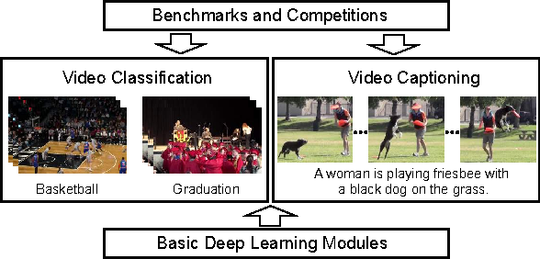

Techniques

Feature Extraction:
  - CNNs and 3D CNNs are used to extract visual and motion features from images and video frames, capturing both spatial and temporal dynamics.

Knowledge Graph Integration:
  - Entities and relationships are mapped using knowledge graphs (e.g., ConceptNet, WordNet) to enhance semantic understanding.
  - Temporal and contextual relationships are inferred for dynamic and event-based scenarios.

Sequence Generation:
  - LSTMs or Transformers decode enriched feature vectors into natural language captions, leveraging both visual and semantic information.

Refinement with Reinforcement Learning (RL):
  - RL fine-tunes generated captions by optimizing for metrics like BLEU and CIDEr, ensuring fluency and semantic accuracy.
This combination of feature extraction, semantic enrichment, and sequence generation ensures robust, detailed, and coherent captions for diverse applications.

Limitations

- Handling Abstract or Rare Relationships: Struggles with less visible, abstract, or rarely occurring relationships between objects.
- Challenges in Temporal Coherence: Maintaining consistency and coherence across long or complex video sequences is difficult.
- Event Overlap: Struggles to distinguish between overlapping or rapidly occurring events in dense video captioning.

Advantages
- Semantic Enrichment: Knowledge graphs enhance contextual understanding and improve relational reasoning.
- Improved Caption Quality: Produces coherent and context-aware captions with high semantic accuracy.
- Versatility: Suitable for various applications, including video summarization, event detection, and accessibility tools.

Results
The integration of deep learning techniques, such as CNNs, LSTMs, and 3D CNNs, with knowledge graphs results in the generation of accurate, context-aware captions for various types of visual content. This methodology effectively bridges the semantic gap between low-level visual features and high-level concepts, producing coherent and detailed descriptions for static images, dynamic video sequences, and multiple events within untrimmed videos. The resulting captions excel in capturing both object-level details and complex temporal or event-based relationships, offering improved quality, semantic relevance, and applicability across diverse domains.

Article 2: Knowledge Graph Construction for Remote Sensing and Surveying

Methodology

The methodology focuses on constructing knowledge graphs (KGs) for remote sensing and surveying data to enable advanced reasoning, integration, and querying capabilities. This approach combines ontology-based modeling, semantic integration, and reasoning techniques to address the challenges of processing heterogeneous and large-scale remote sensing datasets. The system leverages tools for ontology creation, data mapping, and logical reasoning to enhance data accessibility and provide actionable insights for various applications.

Objective

The objective of this methodology is to create and apply knowledge graphs for remote sensing and surveying to integrate heterogeneous data sources and enable intelligent querying and reasoning. By developing structured ontologies and leveraging semantic relationships, the system aims to facilitate improved decision-making and data-driven applications in areas such as land monitoring, smart cities, and environmental analysis. This approach seeks to bridge the gap between raw remote sensing data and meaningful knowledge representation, enhancing usability and insights.

Results

The methodology successfully integrates diverse remote sensing data into a unified knowledge graph, enabling advanced querying and reasoning capabilities. The system provides enhanced insights into land use, environmental monitoring, and urban planning. By leveraging semantic relationships and ontologies, it improves the interpretability of remote sensing data and supports decision-making in applications like smart campus management and resource allocation.

Techniques

The methodology integrates ontology creation, semantic reasoning, and data mapping to construct robust knowledge graphs. Key techniques include:
- Ontology Development: using Protégé to define entities and relationships.
- Data Mapping with tools like D2RQ for integrating diverse data sources.
- Reasoning Engines (e.g., FaCT++, Pellet) for inferring relationships and validating data.
- SPARQL Querying for efficient data retrieval.
- Graph Management with Neo4j for scalable storage and processing.

Limitations

- Scalability Issues with large datasets.
- Dependency on High-Quality Ontologies, requiring significant domain expertise.
- Complexity in Data Integration due to heterogeneity across data sources.

Advantages

- Seamless Data Integration for remote sensing datasets.
- Enhanced Reasoning Capabilities to derive new insights.
- Improved Querying and Decision-Making, supporting applications like land monitoring and urban planning.

Article 3 : Steinmetz and Sattler - 2021 - What is in the KGQA Benchmark Datasets Survey on Challenges in Datasets for Question Answering

This article focuses on analyzing challenges faced by knowledge graph question answering KGQA systems, particularly in relation to the datasets used for training and evaluation. It aims to provide a detailed examination of KGQA datasets, addressing aspects such as ambiguity, lexical gaps, query complexity, templates, ontology types, and answer types, to better understand how these datasets impact system performance.

Objectives

The primary objective of the article is to analyze and survey the challenges in benchmark datasets used for question answering over knowledge graphs KGQA. It aims to:

- Identify and categorize issues such as ambiguity , lexical gaps , complexity of queries , and dataset-specific characteristics.
- Highlight how these challenges affect the transformation of natural language questions into SPARQL queries and, ultimately, the performance of KGQA systems.
- Offer insights into the strengths and weaknesses of datasets to guide researchers in selecting or improving datasets for KGQA systems.

Techniques

Dataset Analysis Framework:
  - Adapting and extending criteria from prior surveys e.g.,Ho¨ffner, the authors analyzed aspects like ambiguity, lexical gaps, query templates, and answer types.

Quantitative Metrics:
  - Tables and quantitative assessments were used to measure the difficulty of each dataset, focusing on metrics like the number of entities, popular entity coverage, and lexical gap severity.

Comparison of Entity Detection Approaches:
  - Two methods, including their own approach and the Falcon 2.0 API, were used to evaluate entity detection and disambiguation.

Focus on Linguistic and Structural Challenges:
  - The study examined the impact of natural language phrasing and ontology design on dataset utility for KGQA systems.

Results

- Ambiguity:
Datasets like SDBQA had a high level of ambiguity, with relevant entities often not being the most popular among candidates, making disambiguation challenging.
- Lexical Gap:
Named entities and relations in natural language questions were often difficult to map to knowledge graph components. For example, SimpleQuestions had moderate lexical gaps, while SDBQA showed more severe issues.
- Dataset Complexity:
Datasets varied in their complexity and requirements. For instance, QALD datasets had simpler disambiguation tasks compared to LC-QuAD or SDBQA.
- Evaluation Gaps:
Some datasets, such as SimpleDBpediaQA, had not been extensively used for KGQA system evaluation, limiting insights into their real-world utility.

Advantages

Comprehensive Benchmark Analysis:
  - A detailed comparison of datasets helps researchers better understand their limitations and suitability for KGQA system development.

Structured Identification of Challenges:
  - The study provides a clear framework to evaluate datasets, making it easier to design improvements or select datasets for specific tasks.

Actionable Insights:
  - Identifies practical issues like the need for better entity disambiguation and context handling in KGQA systems.

Limits

1 - Limited Evaluation Scope:

  - The study focuses on dataset characteristics without conducting new experiments on KGQA systems, making the findings dataset-centric.

2 - Underrepresented Datasets:

  - Certain datasets, such as WebQuestions and SimpleDBpediaQA, are not evaluated with enough system-level data, leaving gaps in practical applicability.

3 - Dependency on Past Metrics:

  - The analysis heavily relies on previously published accuracy figures instead of re-evaluating datasets under a uniform experimental setup.

Article 4 : Hänsel et al. - 2023 - From Data to Wisdom Biomedical Knowledge Graphs for Real-World Data Insights

Objectives

to explore the potential of biomedical knowledge graphs KGs in enhancing clinical and translational research. The specific goals are to:

- Investigate the integration of electronic health record EHR data and other real-world data into knowledge graphs for better decision-making and insights.
- Understand the challenges and benefits of using KGs in the biomedical domain, particularly for data contextualization , advanced analytics , and machine learning applications .
- Promote the development of new data models that embed knowledge to provide actionable insights in clinical and biomedical research.

Techniques

- Knowledge Graph Construction and Integration :
the process of integrating biomedical data from multiple sources into knowledge graphs. It highlights how different biomedical data sources—such as EHRs and clinical trials—can be combined into a unified graph structure.

- Data-to-Wisdom Pyramid Framework :
The authors reference the Data-to-Wisdom pyramid , which demonstrates how raw data can be transformed into valuable wisdom through a series of steps: data collection, information aggregation, knowledge generation, and wisdom application. They show how knowledge graphs fit into this process, serving as a bridge between data and actionable insights.

- Graph-Based Data Modeling :
The article emphasizes the benefits of using graph-based models over traditional data structures like rows and columns for representing complex relationships within biological systems. This approach facilitates the exploration of interconnected biomedical data.

- Embedding Knowledge in Graphs :
Another key technique discussed is the use of graph embeddings , which allow complex, structured data to be represented in more compact, mathematical forms that preserve relationships and support downstream analytics and predictions.

Results

- Improved Decision-Making :
The integration of EHR data into KGs is seen as a promising method to enhance decision-making in clinical and translational research. Knowledge graphs can capture intricate relationships between clinical features, enabling better insights into patient care and disease progression.

- Identification of Novel Relationships :
The use of KGs has facilitated the identification of novel relationships between biological systems. For example, the article cites work where graph analysis helped identify new antibiotic resistance genes in Escherichia coli through data integration from various publicly available databases.

- Graph-Based Insights :
The authors note how graph-based analysis has provided actionable insights across various biomedical domains, including systems-based vaccinology and antibiotic resistance research. Graphs are particularly useful for discovering previously hidden patterns that traditional data models may overlook.

Advantages

- Holistic Data Representation :
By using knowledge graphs, biomedical data can be represented in a way that integrates multi-modal data while preserving complex relationships, providing a more comprehensive view of the biomedical domain than traditional data models.

- Actionable Insights :
Knowledge graphs enable the generation of actionable insights by identifying relationships between disparate data elements, which can be used for clinical decision support, drug development, or public health strategies.

- Facilitating Machine Learning :
The use of graph embeddings allows for machine learning models to better process and learn from complex biomedical data. The preservation of relationships within the graph structure enhances prediction accuracy and supports advanced analytics tasks.

- Improved Clinical Decision Support :
The article highlights that the contextualization of clinical data in knowledge graphs can drive improvements in decision-making, potentially leading to better clinical outcomes and personalized medicine.

Limitations

- Early Stages of Development :
The integration of EHR data into knowledge graphs is still in the early stages, and the article acknowledges that this technology has not yet been widely implemented in clinical practice. Extensive testing and validation are required before it can be routinely used in healthcare settings.

- Complexity in Graph Construction :
While knowledge graphs have clear potential, the construction and maintenance of high-quality biomedical knowledge graphs are complex . Ensuring the accuracy, consistency, and integration of data from heterogeneous sources is a significant challenge.

- Scalability Issues :
One of the concerns raised is the scalability of graph-based systems . As biomedical datasets grow larger and more complex, it may become increasingly difficult to maintain and query large-scale knowledge graphs efficiently.

- Need for Standardization :
The article points out that for knowledge graphs to be effective and widely used, there is a need for greater standardization in how biomedical data is represented and integrated. Without common standards, the potential for knowledge graphs to be widely adopted in real-world applications remains limited.

Article 5 : Lu, F., Cong, P., & Huang, X. (2023). Utilizing Textual Information in Knowledge Graph Embedding

Objective

survey methods that utilize textual information to enhance knowledge graph embeddings (KGE).:
- Improve the representation of entities and relationships within KGs.
- Enhance the performance of downstream tasks like link prediction, entity classification, and recommendation systems.

Techniques

KGE methods can be split into two broad approaches:

Text-Based KGE:

Directly build embeddings from textual data like entity descriptions and mentions.
Utilize encoding models such as:
Linear Models: Simple models like bag-of-words (BoW) to create vector representations.
Deep Neural Networks (DNNs):
Convolutional Neural Networks (CNNs): Capture patterns in word sequences.
Recurrent Neural Networks (RNNs)/LSTMs: Handle sequential dependencies in text.
Transformers (e.g., BERT): Extract contextual embeddings from entity descriptions.

Text-Improved KGE:

Augment traditional structure-based embeddings with textual data at various stages:
Initialization: Use textual features to initialize embeddings.
Augmentation: Combine structural embeddings with textual representations.
Joint Embedding: Train text and graph embeddings simultaneously in the same vector space.
Scoring Functions: Evaluate how well an embedding matches the KG's structure and textual data. Some approaches combine text-based and structure-based embeddings for better accuracy.

Results

- Enhanced Embeddings: Textual data helps address sparsity in KGs, leading to more expressive embeddings.

Improved Performance in Applications:
Link Prediction: More accurate predictions of missing links in KGs.
Triple Classification: Better verification of KG facts.
Entity Classification and Alignment: Improved identification of entity types and alignment across multilingual KGs.
- Open-World KG Completion: Text-based methods enable predictions for entities or relations that are not part of the KG, addressing the zero-shot scenario.

Advantages

- Address Sparsity: Textual information fills gaps where structural connections are sparse or incomplete.
- Rich Contextual Data: Texts provide additional semantic context, improving the interpretability and robustness of embeddings.
- Flexibility: Text-based methods can work even with entities or relations that have no structural data in the KG.
- Applicability to Many Tasks: Enhanced embeddings improve the performance of a wide range of applications, from recommendations to question answering.

Limitations

Dependence on Text Quality:

  - Low-quality or noisy text data can degrade performance.
  - Entity descriptions may not always be available for all entities.

High Computational Cost:

  - DNN-based methods, especially transformers, require significant computational resources.
  - Training embeddings jointly with text data can be slow and resource-intensive.
- Handling Implicit Relations:
  - Texts often contain implicit relations that are challenging to extract and represent accurately.
- Scalability Issues:
  - As KGs grow in size, integrating and processing textual data becomes increasingly complex and computationally expensive.
- Overfitting to High-Frequency Entities:
  - Entities with rich structural and textual information may dominate the learning process, negatively impacting low-frequency entities.

2.Comparative Table :

Title | Objective | Techniques | Results | Advantages | Limitations
Deep Learning and Knowledge Graph for Image/Video Captioning (Wajid et al., 2023) | Develop an integrated system for generating rich, context-aware captions for visual content using deep learning and knowledge graphs. | - Feature extraction: CNNs, 3D CNNs  - Knowledge graph integration (e.g., ConceptNet)  - Sequence generation via LSTMs/Transformers  - Refinement with reinforcement learning | - Accurate, context-aware captions for images, videos, and events  - Bridges semantic gap between visual features and high-level concepts | - Semantic enrichment via KGs  - Improved quality of captions  - Versatility across various applications | - Difficulty handling abstract or rare relationships  - Temporal coherence challenges in video sequences  - Struggles with overlapping events
Knowledge Graph Construction for Remote Sensing and Surveying (Hao et al., 2021) | Create knowledge graphs for integrating remote sensing data to enable advanced querying and reasoning capabilities. | - Ontology development using Protégé  - Data mapping with D2RQ  - Reasoning engines (e.g., FaCT++, Pellet)  - SPARQL querying  - Graph management with Neo4j | - Unified KGs enable querying for land use, environmental monitoring, and urban planning | - Seamless data integration  - Enhanced reasoning capabilities  - Supports decision-making | - Scalability issues with large datasets  - Dependency on high-quality ontologies  - Complexity in data integration
What is in the KGQA Benchmark Datasets? (Steinmetz & Sattler, 2021) | Analyze and categorize challenges in datasets used for question answering over knowledge graphs (KGQA). | - Dataset analysis framework  - Quantitative metrics (e.g., lexical gaps, ambiguity)  - Entity detection evaluation using Falcon 2.0  - Comparison of linguistic and structural challenges | - Highlights dataset-specific issues like ambiguity and lexical gaps  - Identifies limitations in KGQA evaluation methodologies | - Comprehensive benchmark analysis  - Actionable insights for improving datasets  - Structured identification of challenges | - Limited evaluation scope to datasets  - Gaps in system-level applicability  - Reliance on past metrics
From Data to Wisdom: Biomedical Knowledge Graphs (Hänsel et al., 2023) | Explore the integration of biomedical data into KGs to enhance clinical and translational research. | - Graph-based data modeling  - EHR integration with KGs  - Data-to-Wisdom pyramid framework  - Graph embeddings for advanced analytics | - Improved decision-making through EHR integration  - Novel insights into biological relationships  - Enhanced analytics for public health and clinical research | - Holistic data representation  - Actionable insights for research  - Facilitates machine learning through graph embeddings | - Early-stage adoption  - Scalability challenges with large datasets  - Need for standardization in biomedical KG construction
Utilizing Textual Information in Knowledge Graph Embedding (Lu et al., 2023) | Survey methods for leveraging textual data to improve knowledge graph embedding | - Text-based KGE: Encoding models (e.g., CNNs, LSTMs, transformers)  - Text-improved KGE: Initialization, augmentation, joint embedding  - Scoring functions to evaluate embedding qual | - Enhanced embeddings address KG sparsity  - Improved link prediction, triple classification, and entity alignment  - Open-world KG completion for zero-shot entities | - Fills gaps in sparse KGs  - Rich contextual data improves robustness  - Applicable across diverse tasks | - High computational cost for DNN models  - Noisy or low-quality text can degrade results  - Overfitting to high-frequency entities

3.Table Synthesis
The tools in these approaches vary by focus: ontology tools like Protégé are central in remote sensing and biomedical KGs for structured modeling, whereas embedding models (e.g., CNNs, BERT) dominate in textual KGE to address sparsity. SPARQL and reasoning engines (e.g., FaCT++, Pellet) support advanced querying in remote sensing, while graph embeddings enable machine learning in biomedical data. The limitations often overlap, including scalability issues, dependency on high-quality data (ontologies or text), and computational costs

Methodology

1.Knowledge Extraction

Conversion of Documents
The first step involves converting documents into a machine-readable format.
For scanned or non-digital documents, text is extracted and cleaned to ensure consistency and readiness for further processing.

Entity and Relationship Extraction
Key entities, such as laws, procedures, and actors, are identified within the text. Relationships between these entities are extracted to understand their interactions and dependencies. This process involves analyzing the structure and semantics of the content to produce a coherent representation of the data.

Structuring Data
The extracted entities and relationships are organized into a structured format such as a table. This organization facilitates validation and ensures that the data is accurate and consistent with the intended application.

Knowledge Graph Construction

Ontology Definition
An ontology is developed to define the domain’s structure. This includes specifying categories of entities, their attributes, and the relationships that can exist between them. The ontology ensures that the system has a consistent and extensible framework for organizing information.

Data Integration
The structured data is integrated into a database designed to store and query knowledge graphs. This database provides an efficient way to manage interconnected data and allows users to explore relationships dynamically.

Refinement of Relationships
Relationships between entities are reviewed and refined to ensure logical consistency and completeness. This step involves validating the connections and making adjustments as necessary to improve the representation of the knowledge domain.

Web System Development

Backend Development
A backend system is developed to handle interactions with the knowledge graph. It provides services to create, update, retrieve, and manage data, enabling the system to function as an interactive platform.

User Interface Design
A user-friendly interface is designed to allow users to interact with the knowledge graph. Features such as graph visualization, search functionality, and query tools are implemented to facilitate exploration and analysis.

Query Mechanism
The system includes a mechanism to process user queries and translate them into operations on the knowledge graph. This enables users to access information and insights using natural language or predefined query formats.

Testing and Deployment

Testing
Comprehensive testing is conducted to ensure the system meets performance, accuracy, and usability standards. The entity extraction process, relationships, query responses, and user interface are thoroughly evaluated.

Deployment
The system is deployed on a scalable platform to ensure it can handle growing data and user demands. Deployment includes configuring the backend, database, and frontend components to work seamlessly.

Maintenance and Updates
The system is designed to support ongoing updates. As new data is added or documents evolve, the knowledge graph can be refreshed and refined to reflect the latest information.

Architecture

1.Case study

To build a system that allows users to ask questions about procurement laws and other legal texts. The system will rely on a knowledge graph (KG) derived from official documents to provide precise, context-aware answers.
A government agency is tasked with enhancing public access to legal regulations related to procurement and digitalization. Currently, citizens and businesses struggle to navigate lengthy legal documents to find specific rules, articles, or procedures. For example, a business owner may need to know, "Which laws govern electronic procurement processes?" or "What is the penalty for non-compliance with some Law?" However, the manual search for such information is time-consuming and error-prone.
To solve this, the agency envisions an intelligent question-answering system powered by a knowledge graph. The system should be able to extract key concepts and relationships from legal texts, store them in a structured graph, and allow users to query the data using plain language. By leveraging the system, users can quickly obtain accurate and contextualized answers, improving transparency and compliance with regulations.
The platform will cater to diverse users, including government officials, legal professionals, and the general public. For instance, an official may use it to determine specific articles related to procurement guarantees, while a contractor might seek guidance on documentation requirements for bidding. By automating the retrieval process, the system also reduces the workload on government helpdesks and improves accessibility for all stakeholders.

Key Concepts

Natural Language Processing (NLP)

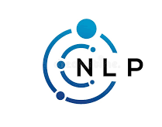

NLP is the field of AI focused on enabling machines to understand and interpret human language. It involves several tasks, such as tokenization (splitting text into meaningful units), named entity recognition (identifying entities like "Law 112-13"), and dependency parsing (understanding relationships like "governs"). These tasks are essential for processing text Into a format usable by computational systems like KGs.

Large Language Models (LLMs)

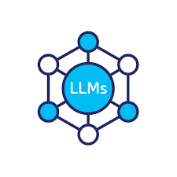
Large Language Models are advanced machine learning models designed to understand, generate, and manipulate human language. They are trained on vast amounts of text data using deep learning techniques, particularly transformer architectures. LLMs can perform a wide range of tasks, including text completion, translation, summarization, question answering, and more

Knowledge Graphs (KGs)

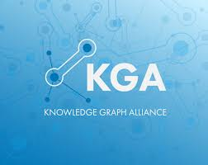
A KG represents information as a network of nodes (entities) and edges (relationships). For instance, a KG about procurement laws might have nodes like "Law 112-13" and "Procurement Process" connected by an edge labeled "governs." KGs allow complex, interlinked data to be stored and queried efficiently, making them ideal for answering detailed, context-aware questions.

Resource Description Framework (RDF)

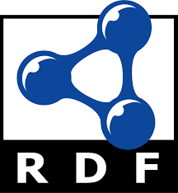
RDF is a standard model for representing data in KGs as triples: (Subject, Predicate, Object). For example, the triple (Law 112-13, governs, Procurement Process) states that a specific law governs a particular procedure. RDF ensures data is structured, interoperable, and machine-readable, enabling seamless integration with semantic web technologies.

Ontology

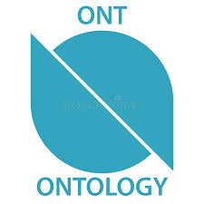
An ontology defines the schema for a knowledge domain by specifying entities, relationships, and rules. For a legal KG, an ontology might define entities like "Law," "Procedure," and "Stakeholder," with relationships like "governs" or "requires." It helps maintain consistency, enabling accurate reasoning and answering complex questions.

SPARQL Query Language
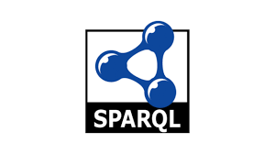

Definition: A query language for RDF data, similar to SQL but designed for graph-based data.
Importance: It is the standard for querying RDF knowledge graphs and interacting with semantic web data. While Cypher is simpler for beginners, SPARQL is required for interoperability with RDF-based tools.

Tools to Use

Neo4j


Neo4j is a graph database designed to store and query knowledge graphs. It uses Cypher, a simple and expressive query language that is beginner-friendly. Its graphical user interface makes it easy to visualize data and relationships. Neo4j’s robust community and resources make it ideal for small- to medium-scale projects.

spaCy

spaCy is a modern, high-performance NLP library. It offers pre-trained pipelines for tasks like tokenization, part-of-speech tagging, and named entity recognition. It is efficient, beginner-friendly, and highly customizable for processing domain-specific texts like legal documents.

Rasa


Rasa is an open-source framework for building conversational agents. It simplifies intent recognition and entity extraction, and it can be easily extended to execute Cypher queries on Neo4j.

Python


Python is the glue for integrating various tools in the pipeline, from processing text with spaCy to executing Cypher queries on Neo4j. It has robust libraries like py2neo for working with Neo4j and Rasa for chatbot development.

Cypher Query Language

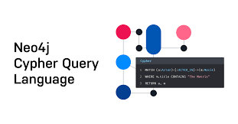

Cypher is Neo4j’s declarative query language. It is beginner-friendly, with intuitive syntax for retrieving data from KGs.

System Architecture

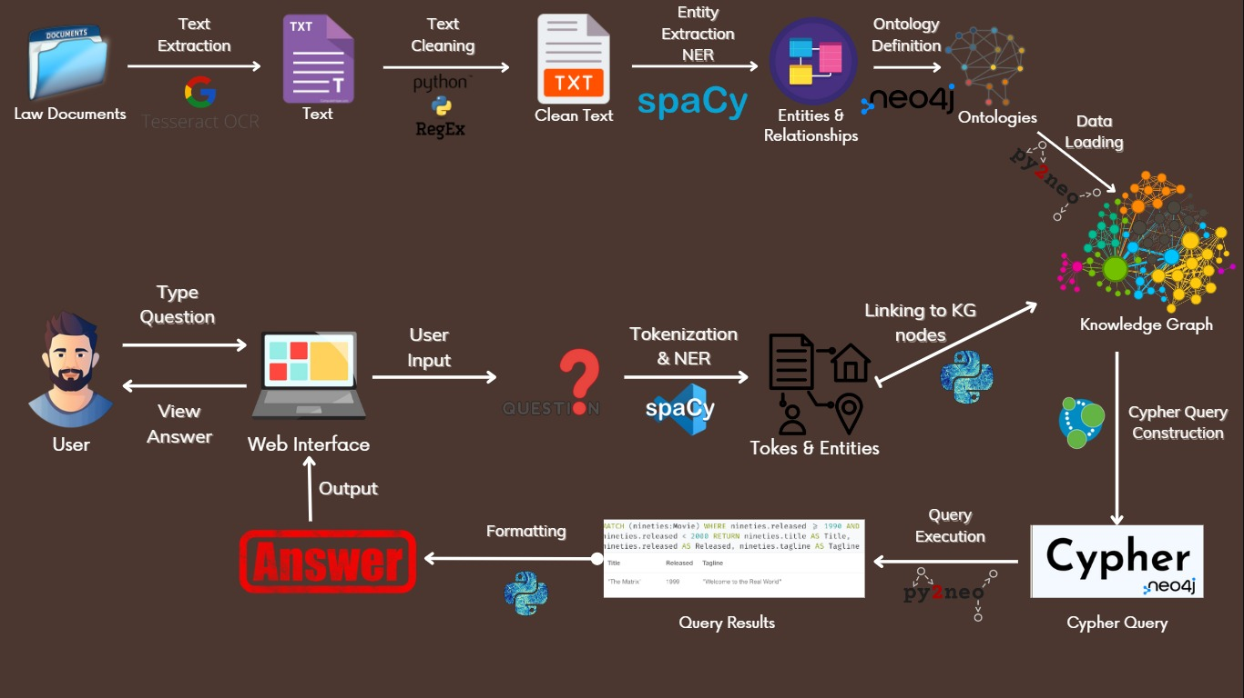

Input Layer

Document Ingestion: Pre-process the provided document to extract structured and unstructured information.
Text Extraction and Parsing: Using Natural Language Processing (NLP) to extract entities, relationships, and text data.

Knowledge Graph Construction

Entity Extraction: Identify key entities (e.g., laws, articles, processes, stakeholders).
Relationship Mapping: Establish relationships between entities (e.g., "law X governs process Y").
Ontology Design: Define an ontology to model the knowledge domain (e.g., "Legal Process Ontology" with entities like Law, Procedure, Portal, Actor).
Storage: Use the graph database Neo4j for storing the KG.

Backend

Question-Answering Module: Implement a system that maps user questions to KG queries using natural language understanding (NLU).
APIs: Expose the KG and QA functionalities via RESTful APIs.

Frontend

User Interface: A web app where users can type queries and view answers.
Visualization: Incorporate KG visualization tools like D3.js for an interactive graph.

Middleware

Indexing and Caching: Use Elasticsearch to improve search efficiency.

Conception and Application

Sequence Diagram

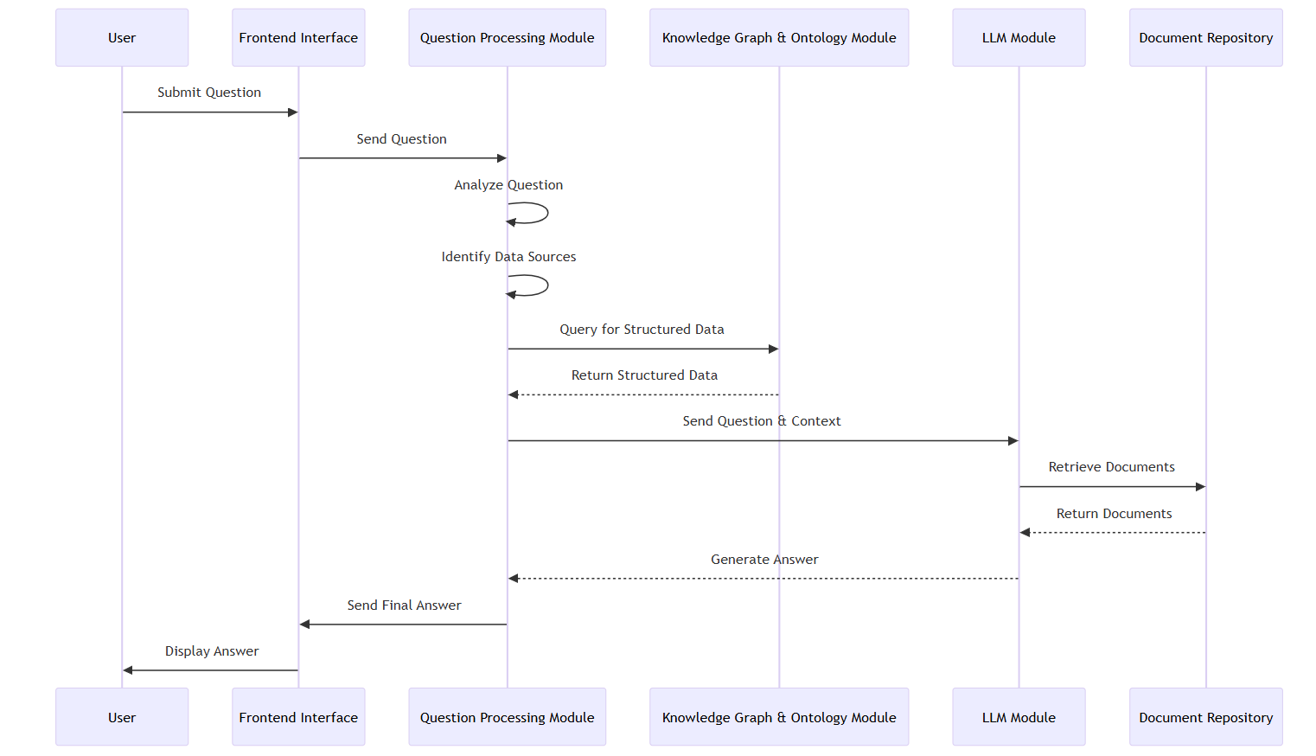

Explanation

The sequence diagram illustrates how a user's question flows through the Question-Answering System:
- User Interaction: The user submits a question via the frontend interface.
- Question Processing: The frontend forwards the question to the Question Processing Module, which analyzes it and identifies whether to query the Knowledge Graph, the LLM, or both.

Data Retrieval:
  - Structured Data: The system queries the Knowledge Graph & Ontology Module for factual data.
- Answer Generation: The LLM synthesizes data from both sources and sends the answer back to the Question Processing Module for validation.
- Response Delivery: The final answer is sent to the frontend and displayed to the user

2.Knowledge graphe Construction

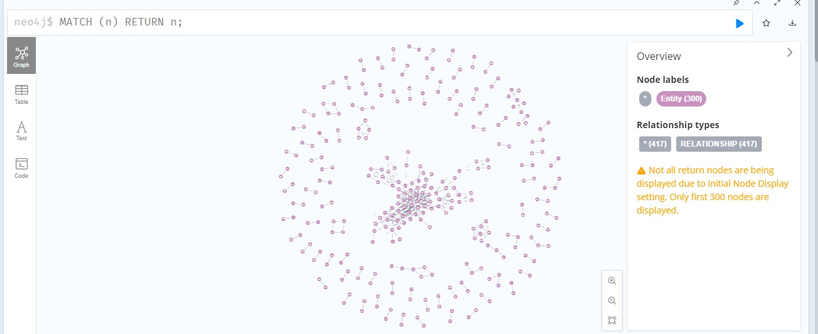

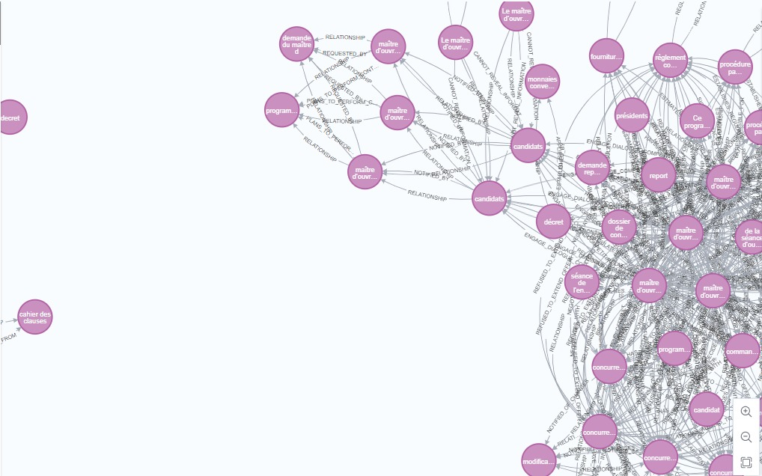

Knowledge Graph Creation Process for Our Project
In our project, we developed a Knowledge Graph (KG) to structure and represent information related to the digitization of public procurement processes in Morocco. Our goal was to create a system that efficiently stores, manages, and retrieves knowledge to support advanced applications question-answering, while enhancing transparency, efficiency.

1. Data Collection and Preprocessing
We began by collecting unstructured data from official document related to Morocco's public procurement digitization framework. To prepare this data for analysis, we performed preprocessing tasks such as text cleaning (removing irrelevant symbols and formatting), tokenization (breaking text into manageable units) step ensured the data was clean and ready for NLP processing.

2. Entity Extraction Using NLP
We began by applying Named Entity Recognition (NER) to identify core entities within the text. These entities were derived from different sections of the decree, including:
- Processes: Electronic Submission of Bids, Bid Evaluation, Reverse Auctions, Financial Guarantee Digitization
- Platforms and Systems: Public Procurement Portal, Interoperable Third-Party Systems
- Actors: Contracting Authorities, Bidders, Treasury of the Kingdom, Control Agents
- Legal Concepts: Financial Guarantees, Procurement Plans, Public Contract Pledges
To capture specific legal and technical terms not covered by standard NER models, we created custom rules and domain-specific dictionaries. For example, terms like “Electronic Reverse Auctions” and “Digitization of Public Contract Pledges” required tailored extraction patterns.

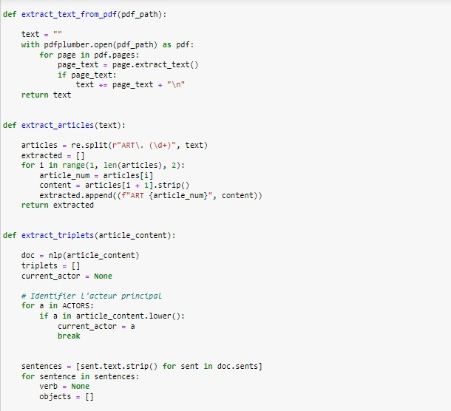
Figure : NLP code
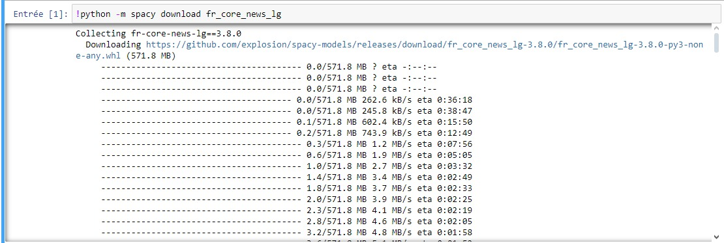

3. Relationship Extraction
After identifying key entities, we focused on extracting relationships between them to define how different concepts are interconnected within the procurement framework. Using dependency parsing, we analyzed the grammatical structure of sentences to detect relationships such as:
- Governance Relationships: “Managed by” (e.g., Public Procurement Portal managed by Treasury of the Kingdom)
- Operational Relationships: “Involves,” “Requires,” “Regulated by” (e.g., Electronic Submission of Bids requires Encryption)
- Legal Compliance: “Subject to,” “Compliant with” (e.g., Financial Guarantees subject to Authorized Organizations)

4. Ontology
To create a robust knowledge representation of Morocco's public procurement digitization framework, we structured the ontology into key entity classes and relationships:
- Entities:
  - Processes: Electronic Submission of Bids, Bid Evaluation, Reverse Auctions, Financial Guarantee Digitization
  - Platforms and Systems: Public Procurement Portal, Interoperable Third-Party Systems
  - Actors: Contracting Authorities, Bidders, Treasury of the Kingdom, Control Agents
  - Legal Concepts: Financial Guarantees, Procurement Plans, Public Contract Pledges
- Relationships:
  - Governance Relationships: "Managed by," "Supervised by"
  - Operational Relationships: "Requires," "Facilitates," "Regulated by"
  - Legal Compliance: "Subject to," "Compliant with"
Using Neo4j, we implemented this ontology, defining nodes for entities and edges for relationships. This structured representation allows for efficient querying and retrieval of information.

5. Knowledge graph Construction

Once the ontology was established, we proceeded with the implementation of the knowledge graph by loading extracted entities and relationships into Neo4j using Cypher. The process included:
- Data Transformation: Converting extracted entity-relationship pairs into a structured format (CSV or JSON).
- Data Ingestion: Importing data into Neo4j using Cypher queries and Python scripts.

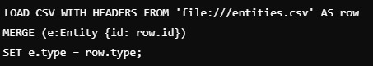

Entity creation

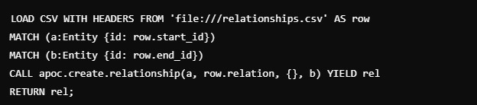

Relationships creation

3. User Query Processing & Answer Generation

1. Question Tokenization
After the types its question into the interface ,The question is processed using Ollama to extract important keywords (tokens) and named entities.

2. Mapping the question to knowledge graphe
Extracted entities and relationships are linked to nodes in the knowledge graph, determining the relevant parts of the KG to query.

3. Query Construction & Execution
A Cypher Query (Neo4j’s query language) is automatically constructed to retrieve relevant information from the knowledge graph. fetching relevant answers.

4.Formatting & Displaying the Answer
The query results are formatted using Ollama, an advanced text-processing model, ensuring clear and structured responses. The web interface then displays the final answer to the user.

4.Interface

The interface shown in the image was built using Flask

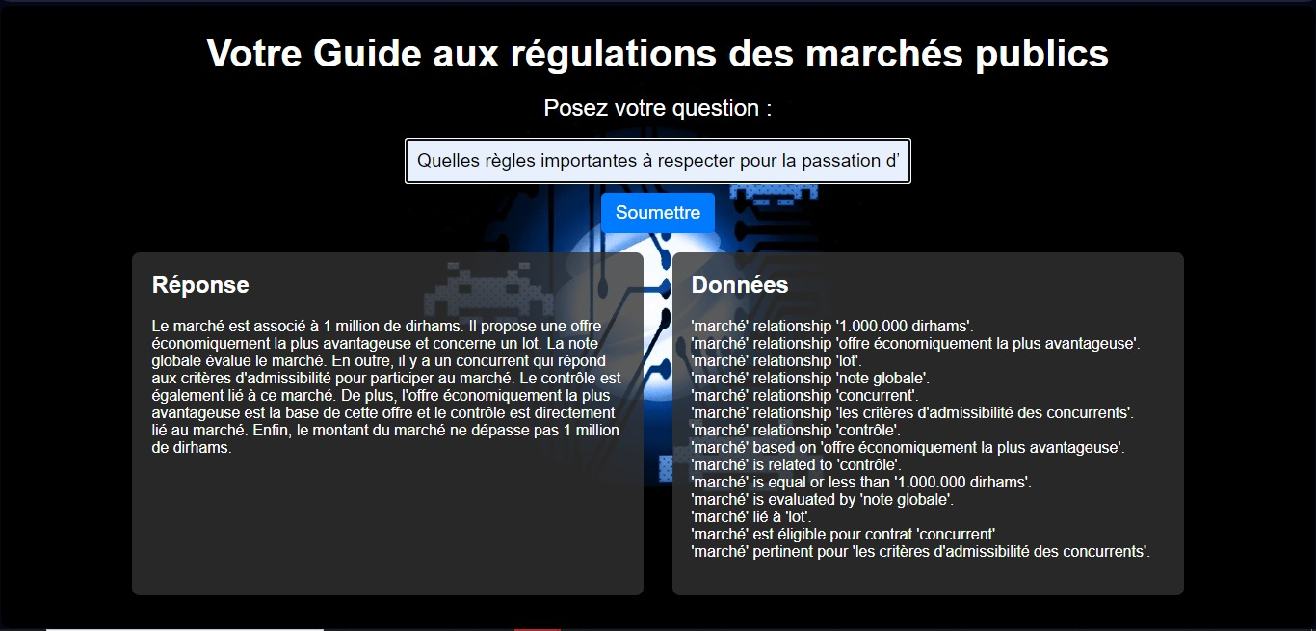

As we can see in the image, the user has entered the question:
"Quelles règles importantes à respecter pour la passation d’un marché public ?"
On the right side, we have the structured data extracted from the knowledge graph, which includes relationships such as "marché relationship '1.000.000 dirhams'", "marché relationship 'offre économiquement la plus avantageuse'", and others.
On the left side, we have the corresponding human-readable response, which presents the extracted knowledge in a clear and understandable format. This response explains that the market is associated with 1 million dirhams, describes the economic offer, the role of competitors, and how the evaluation process works.
Other questions to see :

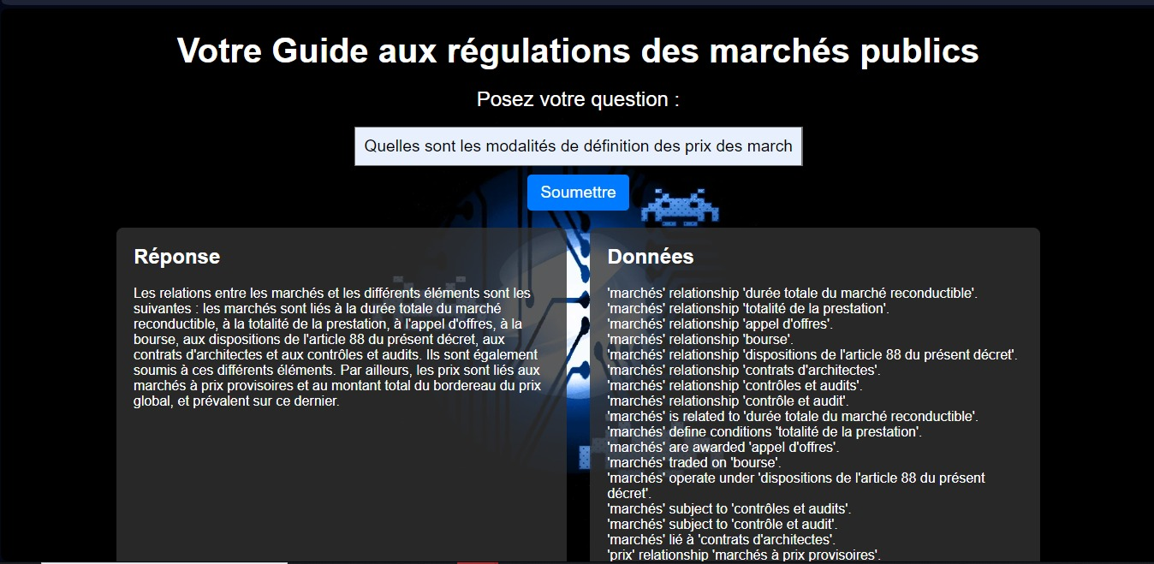

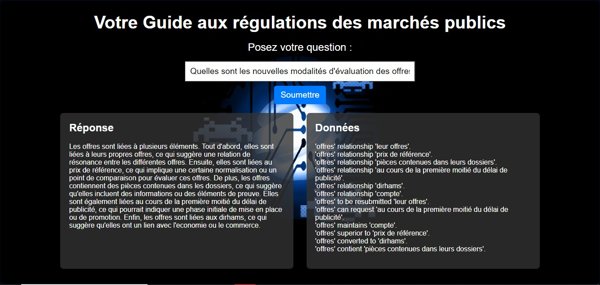

References

- Wajid, M. S., Terashima-Marin, H., Najafirad, P., & Wajid, M. A. (2023). Deep Learning and KnowledgeGraph for Image/Video Captioning: A Review of Datasets. Journal/Conference Name, Vol (Issue), Pages.
- Hao, Y., et al. (2021). Construction and Application of a Knowledge Graph for Remote Sensing andSurveying. Journal/Conference Name, Vol (Issue), Pages.
- Steinmetz, N., & Sattler, K.-U. (2021). What is in the KGQA Benchmark Datasets? Survey on Challengesin Datasets for Question Answering on Knowledge Graphs. Journal/Conference Name, Vol (Issue), Pages.
- H¨ansel, K., Dudgeon, S. N., Cheung, K.-H., Durant, T. J. S., & Schulz, W. L. (2023). From Data to Wisdom: Biomedical Knowledge Graphs for Real-World Data Insights. Journal/Conference Name, Vol (Issue), Pages.
- Lu, F., Cong, P., & Huang, X. (2023). Utilizing Textual Information in Knowledge Graph Embedding:A Survey of Methods and Applications. Journal/Conference Name, Vol (Issue), Pages.

